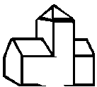
Starting and finishing at
The CHURCH OF THE ASSUMPTION OF
BLESSED MARY &
ST. NICHOLAS

Dates back to 1360 and has many lovely stained-glass windows and brasses and misericords. First mention of a church on this site occurs in 1291 – of this earlier church only a small doorway in the south wall of the chancel remains, which on the outside shows a pointed trefoil head.

Walk through the churchyard to back of the Church and through kissing gates.


Near the church and railway station is the probable whereabouts of Echyngham Manor or Place dating from 1293.

Past VILLAGE POND on left. The young trees on the right are Cricket Bat Willows grown for test match (and ordinary) cricket bats.

(1)
Here we join SHEEPSTREET LANE which is thought to have got its name from “Ship Street” when the River Rother was tidal and barges would sail to and from Etchingham.

Turn right.

A short walk down the lane and over a stile on the left just before the railway bridge.
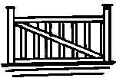
The railway came to Etchingham in 1851.
(2)
Turn right and follow alongside the railway embankment and over a stile next to a gate.

Down a ‘drive-way’ and into a triangular field.
Follow the footpath through this and two more fields until you reach the railway foot crossing. These fields can be very wet or flooded .

A worthwhile diversion is crossing the railway on your right to the Hammer Dyke and Rother Bridges. Here was sited the Echyngham Forge and remains of slag can still be picked up in the corner of the field. Output in 1717 was equivalent to that of any Sussex forge at the time, but by the mid century production seems to have ceased..

Turn left and walk towards the cottage and away from the railway line.
(3)
Over the stile which through the gardens of this cottage.

Through the gate and into a large field.

Walk up the hill keeping to the left of this field.

Half way up:

EITHER turn left and then right to follow the track up to the road, past the back of the new school towards the road.

OR keep straight on up the field:

At the top of the field it is worth a look back northwards over the ROTHER VALLEY.
(4)
Follow through gateway round Pond and wooded area.

Through Gate into Parsonage Croft and on towards the road.

TAKE CARE
DANGER FAST MOVING TRAFFIC - KEEP IN
Turn left and walk down through village until opposite village sign and Oxenbridge Lane. (6)
Walk down through the Village High Street past the Post Office and butchers.
Enter the QUEEN’S GARDENS.

Cross the park via iron gate to the church

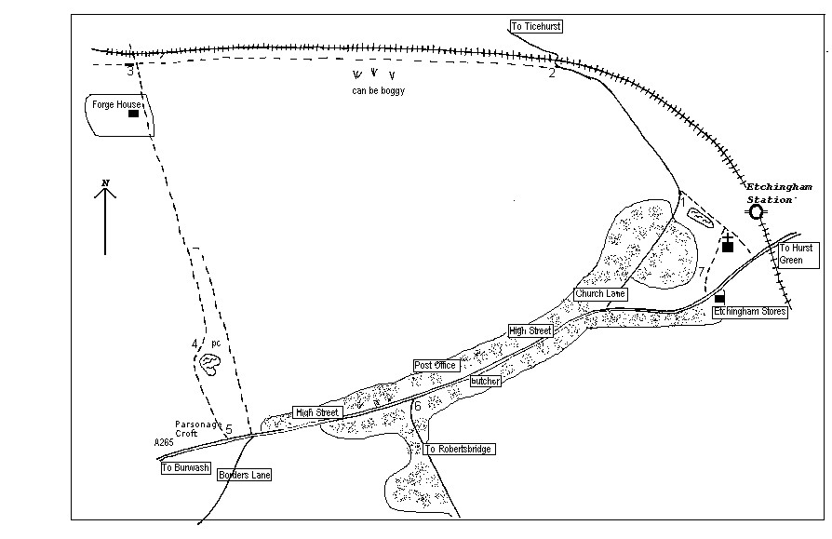

Etchingham Circular

Walk No. 1

By Mrs. S. Cornish

Approx 1 – 1 ½ hours

Updated and reprinted by Etchingham Parish Council
November 2015

