
Starting and finishing at
The CHURCH OF THE ASSUMPTION OF
BLESSED MARY &
ST. NICHOLAS

The church dates back to 1360 and has many lovely stained-glass windows and brasses and miserichords. First mention of a church on this site occurs in 1291 – of this earlier church only a small doorway in the south wall of the chancel remains, which on the outside shows a pointed trefoil head.

Go into the Queen's Garden next to the church. This park was renamed during the 1953 coronation year. Cross the main road to the Etchingham shop (formerly a water mill).

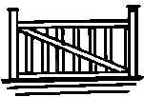
Go to the left of the shop through the kissing gate and over the River Dudwell.

Follow the river bank left for about 20 metres until it bends left – bear right and cross to the gate opposite and go uphill across the field to stiles either side of the farm drive.

Climb over both stiles to far field, Bear right past pond with oaks. From here there is a good view of the Church, Haremere Hall and in the distance the mast by Bedgebury Forest.

Walk down the hill with the tree line on your right. You are now on the western side of the River Rother valley. (the London- Hastings railway line uses the valley and this section os particularly important as few natural north-south corridors exist, most ridges and valleys being oriented East – West. This is a major flood plain and will be under water after prolonged heavy rain.


At the bottom, cross over the stile to your right. Do not follow the footpath over the river, but proceed straight ahead, parallel with the river. (Warning: this stretch can be v boggy). Keep the fence on your left – past pine trees to the next gate with stile, cross into the next field

Go through this field and cross into the next, leave the river and follow the path diagonally though a wooded are and into Gigmore Wood, where there is an old sunken path.

Here – depending on the season, one can see wild flowers, fungi and trees such as Sweet Chestnut, Ash, Elder, Hornbeam and Silver Birch. In spring the Wood Anemones and Bluebells are spectacular. Look our for signs of badgers & deer.

Follow the path through Gigmore Wood and exit into the next field. Turn immediately right and follow round the edge of the field,keeping woods to your right until the cottages are reached. Walk past the cottages and bear left towards the year at Squibs Farm. Turn immediately RIGHT up the farm drive and continue along to the junction with the Oxenbridge Lane. From this lane you can see the obelisk, Brightling Needle.

Turn right and proceed WITH CAUTION along Oxenbridge Lane.

On the left side of this road are the orchards of Athena Farm, protected in places by windbreaks of poplars.

Continue down the lane, shortly, there is a gate on the left, giving a good view point of the village and surrounding countryside.

When you come to the private drive on the right to Churchwood Farm, take the footpath though the small gate on the left at the start of the driveway.

Keeping the hedge on your left, go downhill to the gate between two wooded areas – here on your left is old Woman's Wood and on the right is Church Wood.

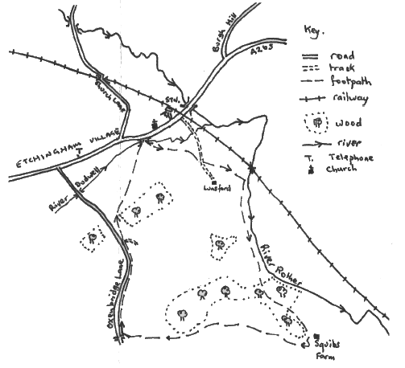
From here you get a good view of Etchingham Village, which is situated on the eastern edge of an east-west ridge rising here above the River Dudwell flood plain, whilst on the right the valley opens into the larger Rother Valley.

Proceed through the gate and diagonally RIGHT down to the corner of the field, over the stile and plank footbridge by the oak tree. Aim for the white weather-boarded buildings near the Church.

Aim to pass to the right of the last building, Here cross over the river Dudwell and go through the metal kissing gate.

Etchingham Circular

Walk No. 2

By Mrs. S. Cornish

Approx 1½ - 2 hours

Updated and reprinted by Etchingham Parish Council
November 2015

