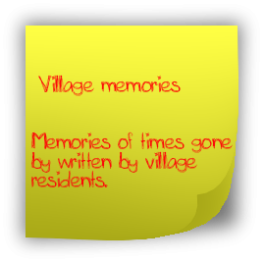
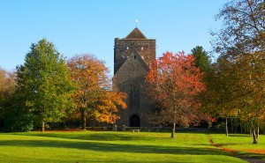
Queen's Garden in the Autumn of 2008.

By Linda Neve
In 1953, to celebrate the Coronation of Queen Elizabeth the Second, the Queen’s Garden was created. I don’t personally remember the Official Opening, but in a photo I have seen, owned by the late Mr Lionel Dengate it appeared to be a wet day as by-standers watching the opening were wearing raincoats and holding umbrellas. In that photo I recognised my Mum together with my eldest brother Brian, and one of my twin brothers, Peter, together with my Aunt and Uncle, Irene and Ernest Wells.
At this time there was just a two seater swing and a seesaw together with a small sandpit. The swings were donated by Mrs Aldridge, owner of the ‘bottom shop’, in memory of her late husband. A footpath ran from the entrance across to a small iron gate in the churchyard wall. Between this path and the roadside hedge there were four flower and rose beds.

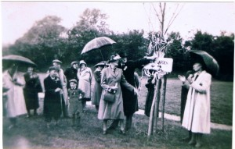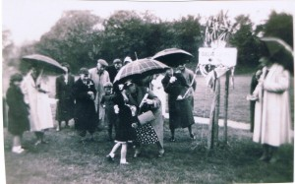
Two pictures of the opening of Queen's Garden in 1953.
Throughout my childhood many happy hours were spent here together with my brothers and other village children, playing on the swings and on the seesaw. The only problem was that when the boys were playing football, the ball often landed in the flower beds and with that Mrs Aldridge would come out of the shop and call “Get off those flowerbeds”.
In the evening Mrs Norris who was Mrs Aldridge’s Assistant would take over those duties and watch from her house, No 1 Clulow Cottages. A friend did remind me the other day that she did come out once with a tray of icepoles for everyone on a hot day. Our other saviour on a hot day was the watertap by the gate in the church wall. Eventually, the flower beds were removed because of the problems they caused. At this time too came nicknames such as the ‘Two Beads’, ‘Turnip’, ‘Sputnick’, ‘Wilbur’, ‘Lub’, ‘Stewpot’ and ‘Stippy’ were used for many years afterwards.
The highlight of the year was the Village Fete which was opened by different people. One of these was an actress called Heather Sears, whose parents lived in Sheepstreet Lane. On another occasion three men from the Improvements Committee, dressed up as the Mayor with a Mace Bearer and another gentleman, but I don’t remember what his role was. They arrived in a Vintage Car owned by Mr Oakley, from Burwash. The big old marquee was erected to house the Tea Tent, - it always had a distinctive small about it. As a child it was so exciting to see what you would get out of the Lucky Dip or win on the Tombola or Hoop-la.
In those days, for the adults, there was a Dartboard and the highest score of the afternoon won 10 shillings (50p) My Dad liked to try his hand and sometimes was lucky to win. When the Fete had finished in the evening, there would be various races run alongside the roadside of the gardens. These were split into various age groups for the boy and girls and also some for the adults. Included were flat running races, egg and spoon, sack races, picking up potatoes, three legged, wheelbarrow race and a special obstacle race for the Mums and Dads which always ended up with the Dads having to thread a needle, which caused my Dad some problems!
On one occasion, I was asked to present the bouquet of flowers to Mrs Hornblower, wife of Colonel Hornblower from The Croft, who was opening the Fete. I remember having to practice my curtsy at home beforehand. Mum made me a lovely pink dress with a frilled collar which also had a lovely big sash around the waist and a big bow at the back.
One year, Miss Bingham, Headmistress of the Primary School, told us we were going to perform some Country Dancing and Maypole Dancing at the Fete. This included having to practise in the Queen’s Garden beforehand. On the day, we changed at ‘The Arms’ (the De Etchingham Arms, sadly closed several years ago) and performed the Country Dancing as best we could with the music coming from an old gramophone player. After that we changed again later to perform the Maypole Dances, which included a single Plait, a Double Plait and the dreaded Cobweb, which if we were not too careful could cause all sorts of problems. Again the music came from the gramophone player, and luckily I think there was just one ‘hiccup’.
While at Primary School we also went to the Queen’s Garden to practice for the Schools’ Sports Day at Robertsbridge Secondary School, as the playground was not suitable. Sometimes, as a treat, we went there to have a game of rounders. Later, when the Scouts and Guides were reformed, there was an extra Fete for them in May when the May Queen would be crowned, and the Scout Band of bugles and drums would lead the Parade down the High Street.
My twin brother John had one nasty experience there when they were playing, - one of the girl’s dogs called Timmy, got rather boisterous and John climbed up one of the trees to get out of its way, when a piece of bark caught him in the eye. He didn’t sleep much that night as his eye was hurting, although my parents couldn’t see anything in it. So the next day, Dad took him to the hospital in Hastings where they discovered a piece of twig stuck under his eyelid. What a relief it was, to get that removed. As we grew up, the Queen’s Garden was still a very popular place to meet your friends. Football and cricket were still played. Now though several of us liked playing tennis, so we invented our own court in the dip. The net was just a string attached to two posts, but we borrowed a marker to make the lines as best as possible. Many happy hours were spent playing but I don’t think any of us were budding Andy Murrays or Chris Everts, as the ground was quite uneven.
Another village boy, Dennis Mills, whose parents owned the other grocers shop in the village, used to practice Discus throwing as he was very good at it although naturally, we all had to stand clear at these times. If there was an older teenager there they would go over to the pub to get us a bottle of pop or packets of crisps. On one of these occasions it was the first time I had tried cheese and onion crisps!
When I was about sixteen, the Improvements Committee decided to hold a Village Flower Show together with the Fete. I personally entered some items in the domestic section, one of which was a decorated sponge which I made to look like a basket with crafted flowers on it. The judge’s comment was that it “was a lovely cake but hardly a sponge.” When the judge, who was Mrs Lethbridge, the vicar’s wife, found out from my Mum that it was my effort, she was so sorry, that she sent me a box of chocolates, as she didn’t want me to be put off by these comments and not enter, another year. Little did she know that over fifty years later I am still entering the flower show.
Nowadays the Flower and Dog Show is held on a separate day with the Flower Show being staged in the Church and the Dog Show in the Queen’s Garden. Before this became the more permanent place to hold it, it was held in the Village Hall and then at Athena Farm in Fontridge Lane. In the year 2000 it was held at the Old Rectory by kind invitation of Mr and Mrs Charles Moore as the Church had been flooded.
Throughout the years before I was married and had a family, the Queen’s Garden was still a focal point for village children. To celebrate the Queen’s Silver Jubilee in 1977 a Fete was held and most of the Stalls were decked out and the Stallholders were all wearing union jack style hats. In the evening there was a tug of war and a football match with all the men dressed as women and vice versa for the women, - all dressed as men.
As the years passed and my four sons, Stephen, Paul, David and Matthew were allowed to go there alone with their friends they spent many happy hours there and at that time the ‘Grant’ land, which is now The Orchard, was an unoccupied area and interesting ‘exploration’ site. The addition of a Basket Ball Ring in Queen’s Garden was also a useful additional ‘plaything’. At some time over the years, the Seesaw was removed owing to Health and Safety issues but ‘baby swings’ were added together with a metal dome shaped climbing frame and at least two benches.
In October 1987 we suffered the hurricane which felled several old trees from Queen’s Garden and it was severely flooded. Therefore in my lifetime it would never look the same again with some of the trees gone. The Improvements Committee asked if anyone would like to donate a tree for planting and my Mum, my three brothers and myself agreed to have a tree planted in memory of my Dad. We chose a beech tree which grows behind the goal post but it has a rather bent trunk. It was rather appropriate as when the goal post was moved there, my Dad had been the Secretary of the Football Club for many years and also played in his younger days. He was also a Founder Member of the Improvements Committee and served on it for many years.
Over time the old swings were replaced when the Queen’s Garden had a major overhaul and two sets of new swings and a small seesaw and bouncy cockerel, together with a slide with a seat and table underneath. There is also what I call the ‘tall obstacle course’ A picnic table and benches were also added.
The entrance has now been moved with new hedging replacing it but the big new main gate also includes a safe entrance gate for people to walk through. I was so pleased that the metal piping frame that was the barrier at the old entrance has been included in the new entrance. The number of children that have ‘swung’ on those railings over the years, are ‘countless’
In the year 2000 a new seat was dedicated to celebrate the Millenium and was placed near the church wall. To sit on it for the first time, were four of the older residents of the village. One was my Mum, Marjorie Mewett, who at that time was the oldest resident who had lived in the village all her life. There was also Mrs Ethel Springett another life long village resident, Mr Lionel Dengate, the oldest gentleman having been here all his life and Mrs Phyllis Bolton, who as a child lived in Hurst Green but went to school at ‘The Oaks’ but then spent the rest of her life in Etchingham.
On at least two occasions a large Village Photograph was take here. I loved it when our grandsons, Thomas and Louis arrived and they also loved to play there. As time has passed by, the Village Fete was organised by the new younger generation of the Village who naturally had different ideas, which were very successful and much enjoyed.
It is very sad that this year 2015, the Fete has not happened, not owing to bad weather but the lack of sufficient helpers to organise it. People don’t realise the effort it takes to pull such an event together and people do need a break from it sometimes, but I praise those people for their efforts over the last few years. Lets hope that in time, some of the new residents of the village will join in village life and partake in such events.
For me the Queen’s Garden will always hold special memories in my heart for all that has happened there in my lifetime, as a child and until now as a mother and grandmother.
Linda Neve (nee Mewett)
July 2015
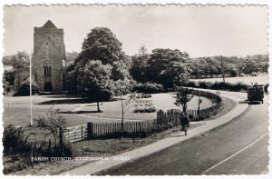
A 1950's postcard of Queen's Garden.

