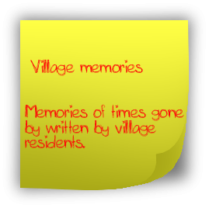
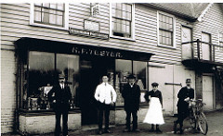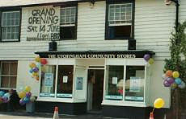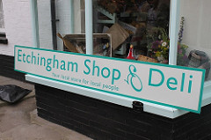

By Ken Thomas
There was a shop on the site from the 1860’s when the South Eastern Railway reached Robertsbridge. Several buildings were built nearby in the traditional Sussex style. One was the Temperance Hotel, long since gone but on the site of the wood yard at the Level Crossing. Another was The Station Inn which was burned down in about 1910 and replaced with the Edwardian Building - The De Etchingham Arms, which closed in the 1990’s and was converted into two dwellings De Etchingham House and Kelsey House. Finally the building now housing The Stores Cottage, Etchingham Shop & Deli and The Coach House
The first shop owner was a Mr George Vigor and he and his family are listed in the 1871 Census. By the 1891 Census the Shop was owned by Mr Laurence Cox and he took it on into the early years of the Twentieth Century. ( I have written another article about Mr Cox and his many suppliers)
So the Etchingham Stores has therefore a long history. Barbara and I were the shop owners from August 1988 until October 31st 1999. Since our time, our successors suffered the floods in October 2000 and the shop was closed. The then owner applied for Planning Permission to turn the whole property into two dwellings. This was refused by the District Council and Parish Council as it was a commercial property. However further Plans converting part of the shop into a separate property, and leaving the rest, were passed.
The Village Community wished however to see a shop re-established and after a couple of Public Meetings and Questionnaires a Steering Group was formed and eventually, The Etchingham Community Shop Association (an Industrial & Provident Society) was set up in October 2002 and raised over £14,000 in £1 Shares, £50 Bonds and Donations which together with a Loan and Mortgage from Rother District Council for over £80,000 purchased the premises from Mr & Mrs T O’Brien in March 2003. The now completely separate Stores Cottage had also been sold.
So from March 2003, with a great deal of good will and some volunteer help from the Village Community the shop was re-furbished and fitted out so that the Community Shop was opened on July 14th 2003 staffed by a paid Manager and Volunteers. It was very well supported during the first few years although the Mortgage and Loan proved to become an increasing burden, needing to be covered from the turnover, every quarter. The first Manager, unfortunately had to resign owing to ill health, in October 2003. A new Manager was appointed and also an Assistant Manager and these two, together with a much reduced but by then, very regular small group of volunteers took the shop forward from 2004 through to 2007. However the second Manager resigned for personal reason in 2007 and a new manager was appointed in November 2007. The trade kept up reasonably well but slowly, with rising costs and falling turnover, inevitably it became impossible to sustain two wages and cover the Mortgage payments.
Thus by 2009 the financial situation was becoming more difficult and it was impossible to raise any more funds either from loans, bank overdraft or the Shareholders. A difficult situation arose in 2010 when the yearly Accounts were not produced in time for the AGM. A further AGM was arranged and a set of Accounts finally produced. Sadly these showed that there was a serious loss on the Trading Account and the inevitable had to be faced. The stock level showed serious depletion with the inevitable loss of customers and further decline in takings meant that the shop would have to close. One of the very few Community shops across the country forced to close. So on April 16th 2011 the Community Shop Door was closed for the last time.
However, salvation was at hand. Once again a shop might be re-established, this time by a Community Interest Company (a Community Business organisation that was instituted in 2005)
In 2008 a group of business people some of whom had not been in the village when the Community Shop had been set up, formed a Community Interest Company with the specific aim of refurbishing the old Station Master’s Cottage at the Station. (A listed building built about 1850 when the South Eastern Railway reached Robertsbridge in 1851)
After many long and difficult negotiations with the Railway Authorities, they succeeded in refurbishing the premises to make a Bistro, opening very early every weekday morning and closing at2.00pm. It opened for business in April 2010. Thus it was able to serve coffee and refreshment to the early morning commuters. Needless to say it has a very dedicated manager and staff able and willing to get up every weekday morning to serve the commuters. The Bistro has now become a great success and a very great addition to the village amenities, particularly as the Village Pub had closed in the early 1990’s.
Seeing the shop was having such difficulties the CIC members offered to help with a ‘Survival Plan’ The Chairman and Shop Committee accepted many of the proposals but circumstances dictated that the shop would have to close, as it did in April 2011.
The CIC again applied for grants and loans and the Parish Council purchased the shop property, so that there is still an important link between shop and community. The shop is however being managed by an individual manager and staff.
Thus once again the shop premises were re-furbished with many alterations being made to the internal structure since our days in the premises. The result however has been a completely new shop inside and it is now called Etchingham Shop & Deli. The new shop opened on May 31st 2012 in the very capable hands of Neil and Sian Cotterill and has once again become a very important village asset. Both Neil and Sian have made it a very pleasant shopping experience and are stocking a very wide range of products. Neil’s qualifications enable him to produce a wide variety of very good meals and the range of deli products is wide ranging.
Once again the village community is fortunate to have a very good shop but must realise that it needs support continuing on into the future.
The tradition of a village shop in these same premises since the 1860’s is being carried on
Ken Thomas
April 2013.
Note; The Shop & Deli ceased trading in 2017, as it was no longer considered viable to run a grocery shop from the premises. Following extensive repairs and refitting, in May 2018 the Parish Council offered a lease to two village businesses, ‘The Wealden Cake Company’ & ‘Find Health & Beauty’, they now share the premises to run their respective businesses.

